Perspective
American Loggers Council to be the National Sponsor of Log-A-Load for Kids

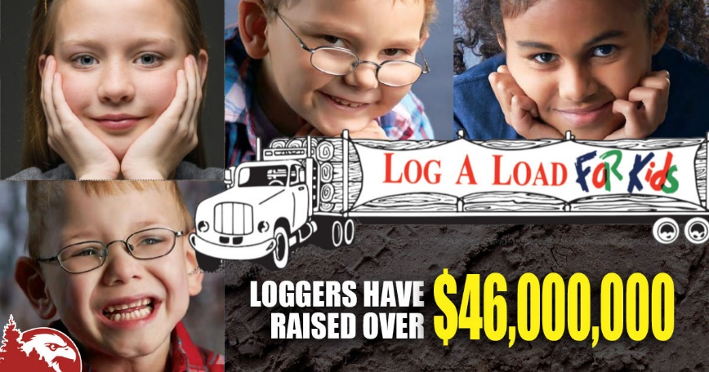
The American timber industry has not experienced a more challenging and difficult period. The current economic and inflationary period is having a more detrimental impact on American loggers and truckers than the housing collapse, “Great Recession” and the COVID pandemic.

Multi-generational businesses are closing, companies are ceasing operations, liquidating, and going into different occupations. It is aggravating and frustrating when owners have invested blood, sweat and tears into building their business only to do the math and see that the numbers don’t add up to staying in business.

Sometimes we can’t see the forest for the trees. Rightfully, the challenges to the industry need to be focused on, but when we step back and see the “big picture”, our challenges and concerns come into perspective. Nothing guides our attention to what really matters more than seeing the most vulnerable suffering health challenges. When a child is sick or injured a family’s world is turned upside down.

Heaven forbid that anyone has a need for their children to go to the hospital, but we thank God that the Children’s Miracle Network Hospitals are available when there is a need.

That is why in 1988 Larry and Carol Connelly, a logging family from South Carolina played a key role in establishing the Log-A-Load for Kids campaign through the Children’s Miracle Network Hospitals Fundraising Telethon. The basic concept was for loggers and wood-supplying mills to donate the value of a load of logs to a local Children’s Miracle Network Hospital. That has evolved into other fundraising events to support the Log-A-Load program, with 100% of the donations going directly to help children. This ensures that families can receive the needed medical services for their children without any out-of-pocket expense.

Since that time, the Log-A-Load for Kids program has spread to over 30 states and raised more than $46 million for 70+ member hospitals. Today, Log-A-Load for Kids is a leader in the Children’s Miracle Network Hospitals’ fundraising with more than $2 million annually through golf tournaments, fishing events, clay shoots, dinners, auctions, truckloads of log donations, and other events.

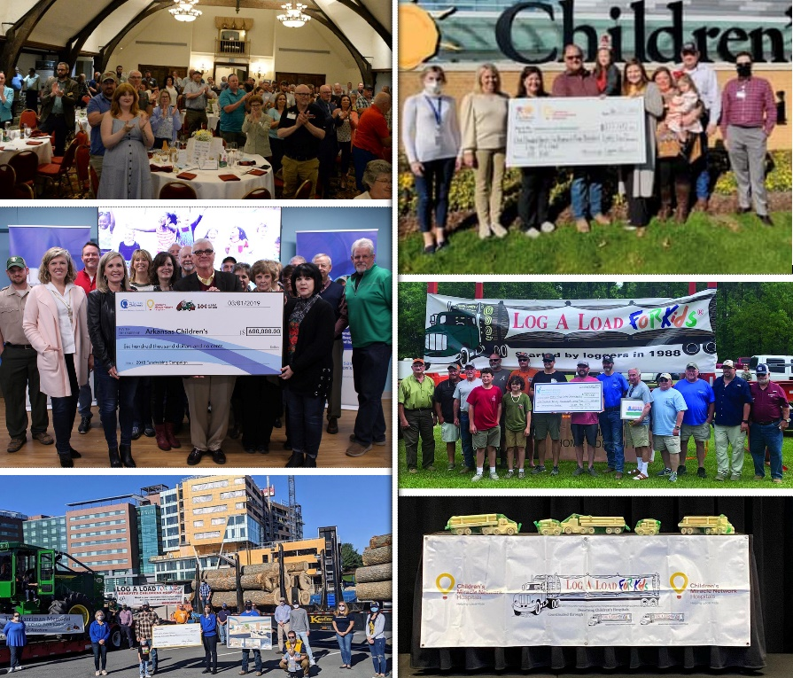
- Florida - Donated over $2 million
- Mississippi -Nearly $2 million
- Arkansas Over $9 million
- Maine - Nearly $2 million
- Mountain Loggers Group - $2 million to Log-A-Load for Kids

Many of the state logging association members of the American Loggers Council sponsor Log-A-Load for Kids events. That is why the American Loggers Council has accepted the opportunity to support the Log-A-Load for Kids program nationally by promoting it and supporting the state efforts. As a demonstration of support, the American Loggers Council has donated six Loggers

Limited Edition Henry Rifles to state association auctions and raffles. These donations have contributed $35,000 to the state efforts.

For the American Loggers Council our purpose is to facilitate, encourage and enable the members – the state logging associations in all their endeavors. The American Loggers Council’s role in the Log-A-Load for Kids program nationally is focused on supporting the leaders of the program, the state logging associations, and contributing to their efforts as they provide for the children in need.

Business and life are about more than the bottom line, it’s about helping when help is needed, it’s about giving back.

Because needs don’t only occur when it is convenient or when we are prosperous, we are called upon to support one another in good times and in bad times. Even during these economically challenging times, loggers have not lost perspective and have continued to donate generously and increasingly to the Log-A-Load for Kids program.

For more info visit: https://www.amloggers.com/log-a-load-for-kids

