The Logging Workforce Development Challenge Pieces Coming Together
This article was written for the Association of Consulting Foresters, by Scott Dane, Executive Director, of the American Loggers Council.
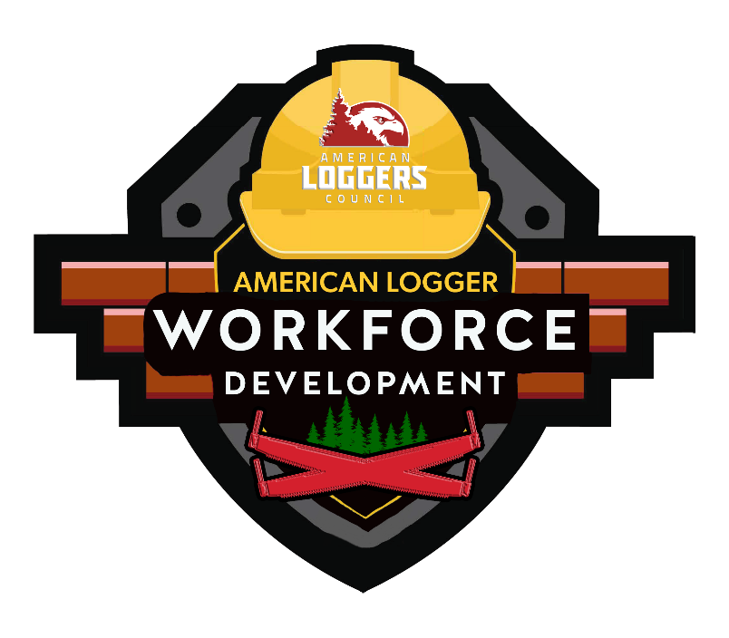
The pieces for workforce development have been identified, but before they can be put together, the elephant in the room must be acknowledged. Regardless of training programs (and there are numerous good ones), the industry needs to be competitive to attract workers.
The existing logging and trucking workforce is aging out at a rate that exceeds those entering the workforce pipeline. This trend will begin to compromise production in the next five to ten years, if not sooner. This issue is further compounded by the fact that the average logging company owner is in their upper 50s. Unless they have a succession plan, such as passing on the company to the next generation – and many do not – then these companies will exercise their "retirement plan" and sell their iron (equipment) and discontinue operations.
American Loggers Council member Jim Houdequin, CEO of Lyme Timber Company, testified recently in the Senate Committee on Energy and Natural Resources where he stated, "Employment in logging has declined by 41% from 86,000 in 1990 to under 50,000 today, a decline of 2% per year. However, logging output has remained nearly flat, so reductions in employment have been almost completely offset by increases in productivity."
Houdequin also described the challenges to workforce recruitment in the logging sector, including low profit margins and wages, physically demanding work, safety challenges, and limited technical training.
So, let’s get back to the elephant in the room. The timber industry is going to remain challenged in its efforts to retain and recruit the workforce necessary for sustainability if it is not competitive. Competitive in wages, benefits, working conditions, and stability. In many instances, Starbucks, fast food chains, and big box stores offer comparable wages and better benefits than entry-level logging jobs. What determines the wage scale and benefits within the timber industry? The amount that logging companies get paid for the wood they deliver. Most logging companies operate on a 3% profit margin, making it prohibitive, if not impossible, to increase wages or offer competitive benefits, so they offer what they can afford and hope for the best.
"I believe the markets for logging services – principally landowners and mills – are beginning to address profit margins and logger compensation, but many of the other challenges cannot be addressed by the private sector alone," Houdequinin also said in his testimony cited above. With that premise in mind, the public and private sectors are waking up to the fact that the workforce challenges represent a current and pending threat to the timber and forest products industries.
Currently, the typical training program in much of the industry consists of a couple of days of best management practices and other topics, then a few hours of instruction on a piece of equipment followed by on-the-job training. With the complexity, technology, and cost of today’s logging equipment, that practice is no longer a viable nor a productive process. Training programs such as the Heavy Equipment and Logging Operations (HELO) program at Shasta Community College in California; the Maine Mechanized Logging Operations Program, administered by Northern Maine Community College; Mississippi’s Logging Equipment Operator Academy, administered through Hinds Community College; and others across the country are beginning to pump trained and productive workers into the employment pipeline. Productivity is the key to getting MORE (production) out of LESS (workers).
Promoting the timber industry’s value, opportunities, and the training process is critical to attracting new workers. The American Loggers Council (ALC) has recently received a $100,000 grant as part of a $250,000 Public Image and Workforce Development grant to improve the public understanding of the timber industry while recruiting new mechanized logging equipment operators. ALC will be working with the state associations to promote their programs, other industry stakeholders to support this initiative, and public/private partnerships to educate the public. Additionally, ALC has been working with the federal government to establish training and investment programs to support the future of the timber industry. The Senate Committee on Energy and Natural Resources, chaired by Senator Manchin and with ranking member Barrasso, has included three provisions in the bill introduced in September that supports state training programs, on-the-job training, and low-interest loan guarantees for the purchase of mechanized logging equipment. See the official language here:
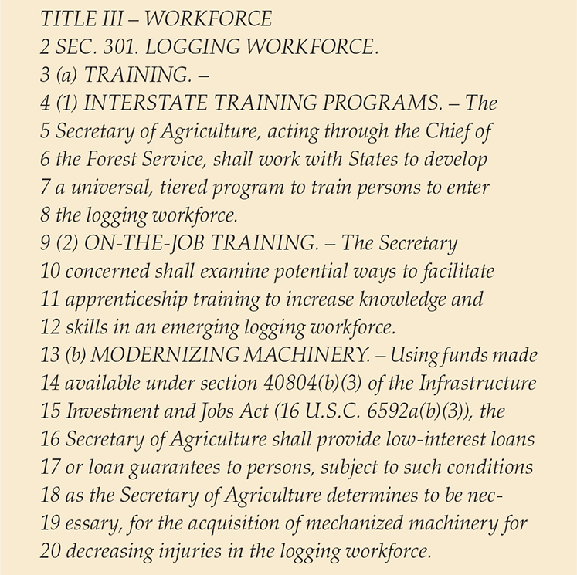
In summary, the first step in solving a problem is acknowledging there is a problem. Based on the facts of the aging workforce, the overall reduction in employment within the logging sector, and the lack of new entry-level workers coming into the timber industry, it is clear that workforce shortages will negatively impact timber harvest capacity if they are not addressed. The second step is developing a solution. Workforce development programs at the state levels; federal government support through legislation and public awareness/promotion will collectively increase the opportunities to recruit and train new mechanized logging equipment operators.
The third step in addressing the workforce development threat and challenges is the competitiveness of the timber industry with reference to comparable industries. This final step in solving the workforce development issue is solely up to the entities that set the rate paid for delivered timber. These entities, the buyers, can invest in the workforce for today and tomorrow. They can ensure the sustainability of the supply chain. They can support the extension of the same level of compensation and benefits as they do for mill workers and other vendors by working with their suppliers to understand their costs.
The pieces to solving the workforce development puzzle are here. The remaining question is whether the players are going to fit the pieces together to safeguard an economically productive wood products industry. The status quo, in the end, I’m afraid, is not sustainable for anyone.

