Missouri, Going Back to Where It All Began
By: Scott Dane, Executive Director

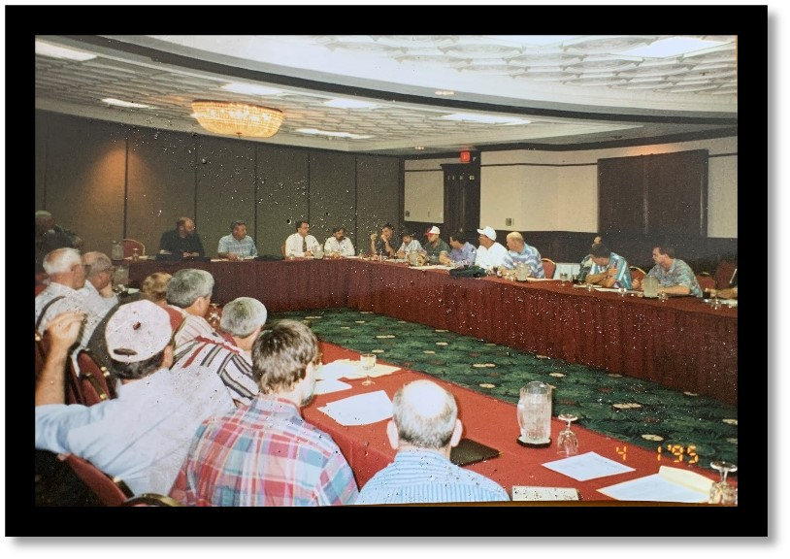
n 1994, loggers from across the country met in St. Louis, Missouri to discuss forming the American Loggers Council, hoping to provide a national voice for the logging sector of the forest products industry. The meeting was precipitated by the American Forests and Paper Association rolling out the Sustainable Forestry Initiative. A program which was initiated without any input from the logging sector, with disregard for the fact that the burden of implementation and compliance was going to lay primarily upon the loggers.

Spearheaded by Earl St. John, and thirty-three other logging leaders from across the country, the meeting was convened, and over the course of a few days the framework of the American Loggers Council was developed.

That was a gutsy move, especially considering that loggers were expected to be seen and not heard within the industry. Though loggers had previously been silent and fragmented, these leaders stood up and said, “We are going to be heard. We are not going to be dismissed and ignored. We are going to be represented!”

As we’ve recently celebrated Independence Day, it is good to recall that the founders of the American Loggers Council, like the founders of the United States, similarly risked personal ramifications, but still, “pledged to each other our lives, our fortunes, and our honor.” In retrospect the risk was worthwhile, as with our nation, so it has been for our organization. The battle belongs to the brave.

Today, the American Logging Council is unquestionably the NATIONAL VOICE OF THE AMERICAN LOGGERS, representing over 30 state and regional associations, nearly 100 Individual Logger Members (ILM), and all major primary industry vendors. You, as a stakeholder in the timber industry, are represented from coast to coast, north to south, from the landing to the halls of Congress.

